Advanced/3D Games Programming
Guide 01a - Creating a DirectX 11 Compatible Project

Introduction

The purpose of this document is to familiarise yourself with the basic aspects of Visual Studio 2015 projects, how to create a default project to enable you to use DirectX 11, and how to easily create new projects based on this template or other projects.

It's crucial that you follow the steps very carefully, if you miss something it can be very hard to find where you went wrong and you may have to start from scratch.

NOTE - you can get a free to use personal version of Visual Studio 2015 Professional for home use whilst you are a student. Go to www.dreamspark.com for details. You will likely need to install the DirectX 11 Software Development Kit (SDK) on your own machine, after installing VS2013 go to https://www.microsoft.com/en-gb/download/details.aspx?id=6812 and download and install the June 2010 DirectX SDK.

Creating a default Visual Studio 2015 project
In this section you will create a default project template that you can use for all the projects in 3D Games programming.
- Make a folder on your U: drive called CGP600 - Your projects will be stored in this folder.
- Open VS2015 and select File→New→Project from the menu bar. The New Project dialog will appear:
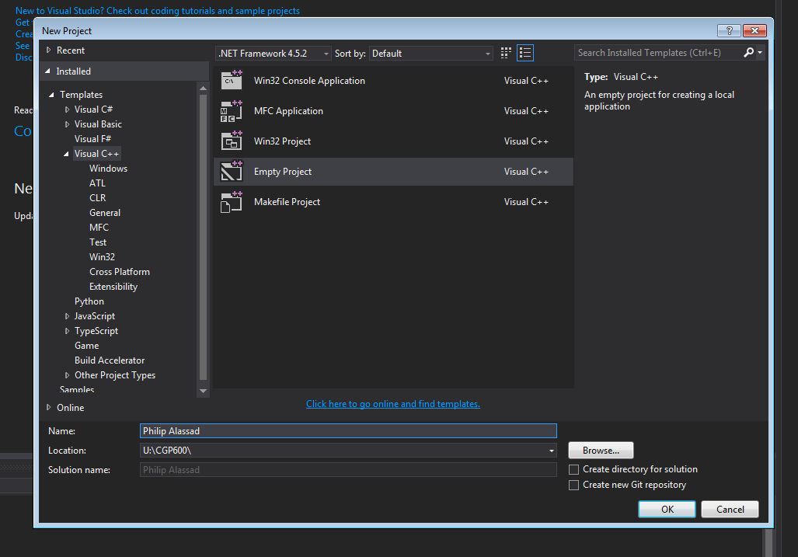
- From the list click on Empty project. In the name field type in name of the project using your name - e.g. Philip Alassad Default Project
- In the Location field type in U:/CGP600\ - the projects for all exercises will be in a subfolder of this folder
- Ensure Create directory for solution is NOT ticked
- Press OK and your project with be created

Configuring the Default Project to use DirectX

You have now created your default project, but you will need to set it up to enable it to use DirectX.

Step 1 - Set up Directory Paths
- If you cannot see the solution explorer tab, select View→Solution Explorer.
- If it is not already highlighted, click on the project (NOT on the solution), see below:
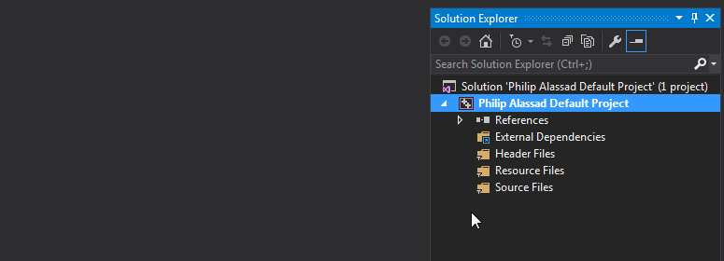

- Select Project→(your project name) Properties. A property pages dialog box similar to this will appear:
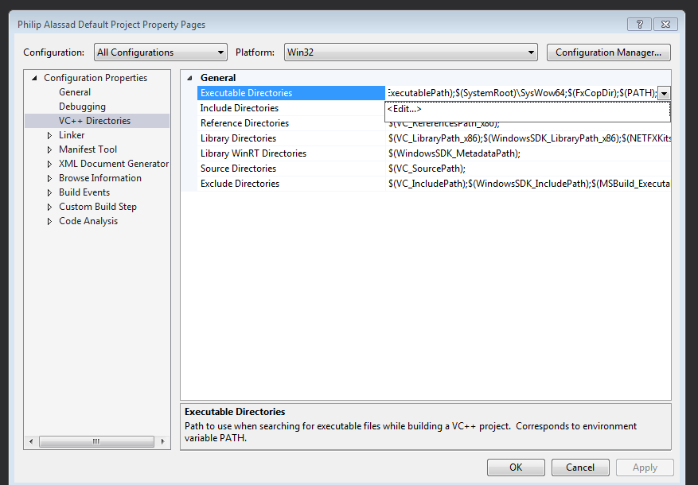

- In the left panel select Configuration Properties. If the submenus are not visible, click on the arrow to show them.
- Ensure the Configuration selector is set to All Configurations, and Platform is set to Win32
- Next, select VC++ Directories→Executable Directories. At the right side of the list of executable directories there is a down arrow, click on this to show the <Edit...> control, as shown below: 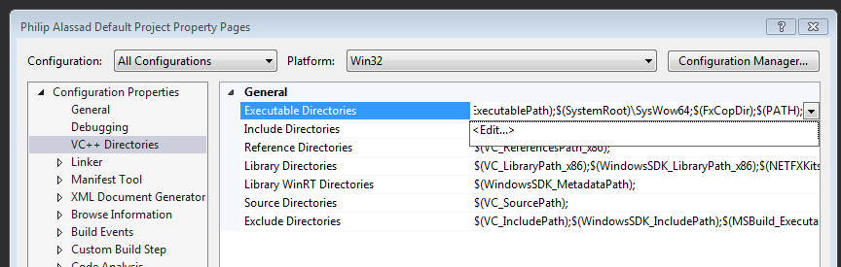

- Select <Edit...> to bring up the Executable Directories dialog:
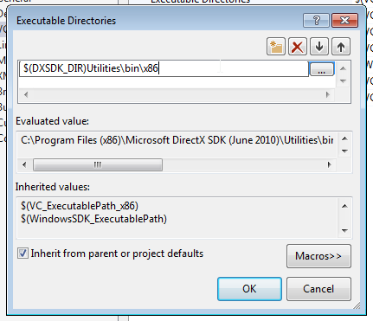

- Double click at the top of the white box, and type or copy:
$(DXSDK_DIR)Utilities\bin\x86
then press OK.
- Select Include Directories, and follow the same procedure as above, except copy the following into the white box:
$(DXSDK_DIR)Include
- Select Library Directories, and follow the same procedure as before, except copy the following into the white box:
$(DXSDK_DIR)Lib\x86
- Click on Apply to save the changes. Don't press OK just yet, there are more configuration settings to be done.

Step 2 - Add Library files
- Set Configuration at the top to Release
- Navigate to Configuration Properties→Linker→Input
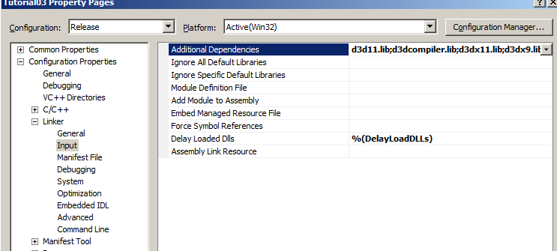

- Click on Additional Dependencies - it will highlight and display a down arrow
- Click on the down arrow - Edit should appear
- Click on Edit - the Additional Dependencies dialog should appear:
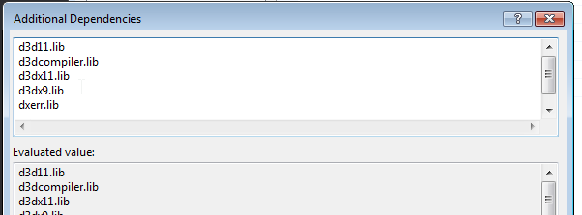
- In the top half of this dialog copy or type in:
d3d11.lib
d3dcompiler.lib
d3dx11.lib
d3dx9.lib
dxerr.lib

then press OK

- Change Configuration at the top to Debug
- Follow the same procedure as before, except this time copy the following:
d3d11.lib
d3dcompiler.lib
d3dx11d.lib
d3dx9d.lib
dxerr.lib

then press OK. (Notice that d3dx11d.lib and d3dx9d.lib are different from the Release libs, the 'd' denotes a debug version)
Press Apply then OK to complete the changes.
Choose File→Save All to save the project, then exit VS2015.
You now have a fully configured project template file that can be used as a basis for most future DirectX projects.

NOTE - do not use this project template directly, always copy and create a new version(see later section)

Understanding and using Visual Studio projects

Visual Studio is an enormously complex piece of software that can be used for a wide variety of applications, and because of this some of the ways it does things can seem overcomplicated to the beginner. To make things easier you will only use basic project setups, but this will still require some explanation.

Visual Studio has a concept of a Solution, which have a .sln file suffix. This is essentially a container for several Projects which have a .vcxproj suffix. Now you've just created a default project, but you may have noticed that the project is part of a solution similar to what is shown below:

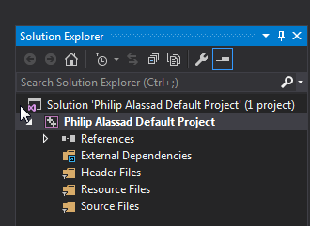

To keep things simple, you will be creating only a single project per solution, which will be named the same as the solution. You in fact should never need to worry about the solution, if you follow the instructions in this document about creating new projects then it will all be handled automatically.

NOTE - To open this simple type of project you can either double click the .sln or the .vcxproj file.

Creating new projects

For most exercises during the unit you will need to create a new project directory and files. Unfortunately there is no automatic way to do this in VS2015, so these instructions will show you a simple way to do this (as long as you have a single project per solution).

NOTE - Don't use this method if you are using a more advanced solution with more than one project.

Sometimes you will want to create a new project from scratch using the default template, but the same process can be used if you wish to use a previous exercise's project as the basis for the new one.

NOTE - the REQUIRED format for project names is [your name][tutorial number][exercise number], e.g. Philip Alassad Tutorial 1 Exercise 3a

- COPY the entire default project (or previous exercise) folder to a new folder and rename the new folder to reflect the new exercise, e.g. Philip Alassad Tutorial 1 Exercise 3a
- Open the new folder and double click on the .sln file to open the project
- Once the project is loaded select Build→Clean [the project name] to delete old unneeded files
- Select File→Save All and close the project
- DELETE the .sln file and Debug folder in the new folder
- RENAME the .vcxproj filters file and VC++ Project file to the same name as the new folder e.g. Philip Alassad Tutorial 1 Exercise 3a.vcxproj
- Double click on the renamed .vcxproj file (NOT the filters file) and the project will be opened and a new solution file created with the new name.
- Select File→Save All and a dialog box will appear - press Save to create the new solution.
- Either close the project or start adding to it.

HINT - you can copy an entire project folder anywhere (e.g. to memory stick), and if you double click on the .sln file it will open normally. This is useful if you want to take the project to work away from university.

NOTE - if you have worked on a project away from the university you should always copy the new work onto the U: drive before you start working during lectures/labs. This is so you have a continuous record of what you have done, but also compiling from memory card is often extremely slow. It's worth backing up any previous old versions already on the U: drive before doing this, e.g. "Philip Alassad Tutorial 1 Exercise 1 - old", just in case there is a problem with the new version.

HINT - if you are pushed for space, for instance you want to email the entire project, use Build→Clean, save and close the project, delete the ipch folder and delete the .sdf file. This will delete all the temporary files that the project uses, which results in a much smaller folder size. Be aware that this deletes the .exe file also, so you will need to rebuild the project in order to run it again.

NOTE - BACKUPS - as you are creating a new project for each tutorial and are required to copy any external work done to the U: drive (which is backed up automatically) then you are reasonably well protected from data loss. However it would be prudent to keep your own backups periodically.

Adding new files to projects

In order to add a file to the project, select Project→Add New Item... You will normally be working with C++ (.cpp) and header (.h) files, so select the appropriate one from the dialog box. In the Name box give the file a suitable name and click on Add. The file will be created, added to the list of files in your project (see Solution Explorer) and will open in the IDE ready for input.

Exercise 01 - Validating the default project

This exercise will help ensure that your default project is correctly set up, as well as getting you into the habit of correctly copying and naming projects.
- Follow the instructions on creating a default project.
- Follow the instructions on how to copy and rename the default project, so that you end up with a new project called [your name] Guide 01a Exercise 01.
- Add a new file called test.cpp to the new project.
- Copy and paste the following code into test.cpp:

#include <windows.h>
#include <d3d11.h>

int WINAPI WinMain(HINSTANCE hInst, HINSTANCE hPrev, LPSTR lpCmd, int nCmdShow )
{
D3D11CreateDeviceAndSwapChain( NULL,
D3D_DRIVER_TYPE_REFERENCE,
NULL,
NULL,
NULL,
NULL,
D3D11_SDK_VERSION,
NULL,
NULL,
NULL,
NULL,
NULL );
}

Don't worry about what this code means, it doesn't actually do anything sensible. All it does is call a Direct3D 11 function to test that DirectX11 has been properly set up in the default project.
- Press F7 to compile the project. (don't bother to run or debug the program, it will just either do nothing or crash)
If the compilation succeeds then your default project should be correctly set up for DirectX11. If not, take a look at the error messages in the Output window as they may give you an idea of what was missed (don't be afraid to google the error messages and codes). If you cannot find and fix the problem within 15 minutes start again from scratch taking care to precisely follow the instructions.

Exercise 02 - Copying an existing project

This exercise will help ensure that you can create a new project from an existing one that you are going to extend, as well as getting you into the habit of correctly copying and naming projects.
- Follow the instructions on how to copy and rename an existing exercise, in this case the Exercise 1 project folder, so that you end up with a new project called [your name] Guide 01a Exercise 02.
- The new project should be an exact copy
- Add the following line of code inside WinMain():

MessageBox(NULL,"Hello World!","[Your Name]", MB_OK);

- Press F5 to compile and run the project.
If the compilation succeeds and the program runs then you should see a message box saying "Hello World!", titled with your name. Because it also has the D3D11CreateDeviceAndSwapChain() call then it is shows that it is still a DX11 compatible project.
Finally, go back and open the Exercise 1 project, and check that it doesn't have the message box code. If it does, then you have not managed to correctly copy things and the Exercise 2 project is sharing Exercise 1 source files. THIS IS NOT GOOD. If you end up in this situation then changes you make to new exercises will alter or break the older ones. If this is the case in these exercises your best bet is to delete everything and start again.

